**Data Visualization**

**The Report (Demo Verson) – COVID-19 DASHBOARD**

**Group: TATT Statistics**

1. **Group ’s members:**

Trương Thái Ngọc **T**oàn  ITDSIU19057

Lý Minh **T**rung ITDSIU19023

Mai Đặng Nhật **A**nh ITDSIU19031

Phan Hưng **T**hịnh ITDSIU19055

1. **List of features:**
2. Covid-19 World Map
3. Covid-19 Line Chart
4. Covid-19 Data Table for each continent
5. Sidebar to select the above features
6. **The current verson (Demo)**
7. 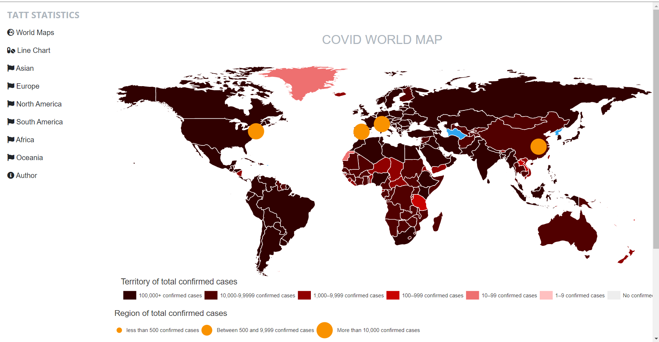The first page: Covid-19 World Map

We will add more cities just like the circle

1. The second page

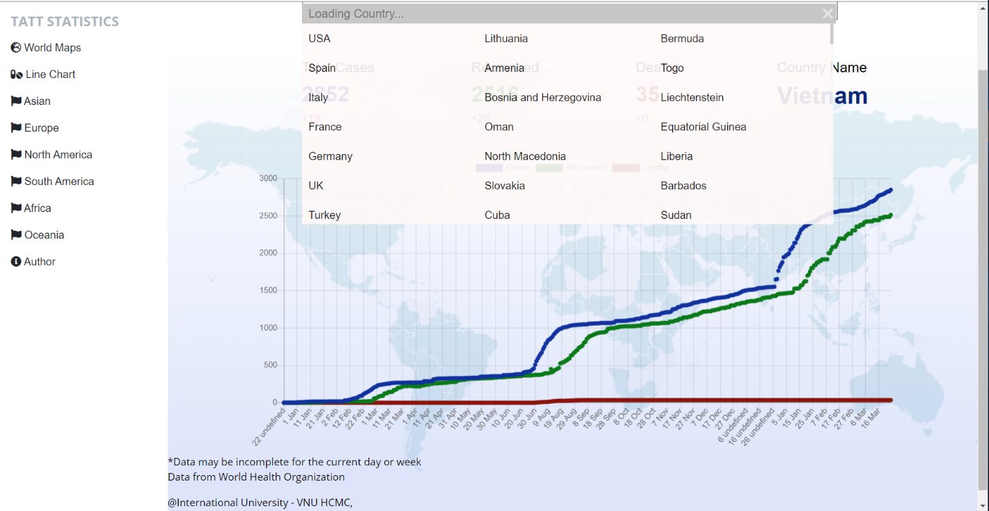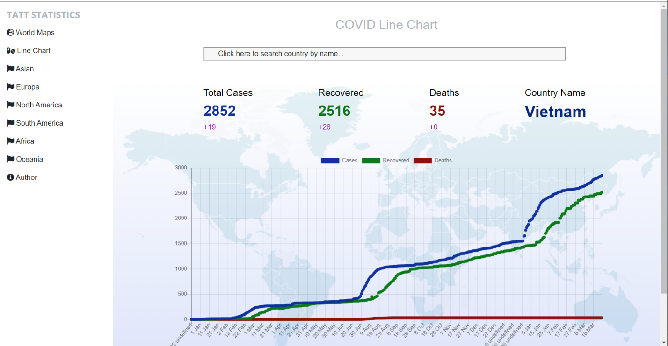

1. **Design**
2. Data type: Ratio
3. Mark:

* World Map: Area
* Line Chart: Line

1. Channel:

* World Map: Position
* Line Chart: Position

1. **Plan for the remaining features**

|  |  |  |
| --- | --- | --- |
| Time | Task | Progression |
| 1/3/2021 - 15/3/2021 | World Map | þ |
| 15/3/2021 - 1/4/2021 | Line Chart | þ |
| 25/4/2021 – 10`/5/2021 | Covid-19 Data Table for each continent | ý |
| 15/3/2021 - 1/4/2021 | Sidebar | þ |
| 1/4/2021 - 20/5/2021 | Author | ý |